# Integer Clock Divider

Under supervision of:

Eng. Ali Eltemsah

Submitted by:

Ali Yehia Abdelmonem

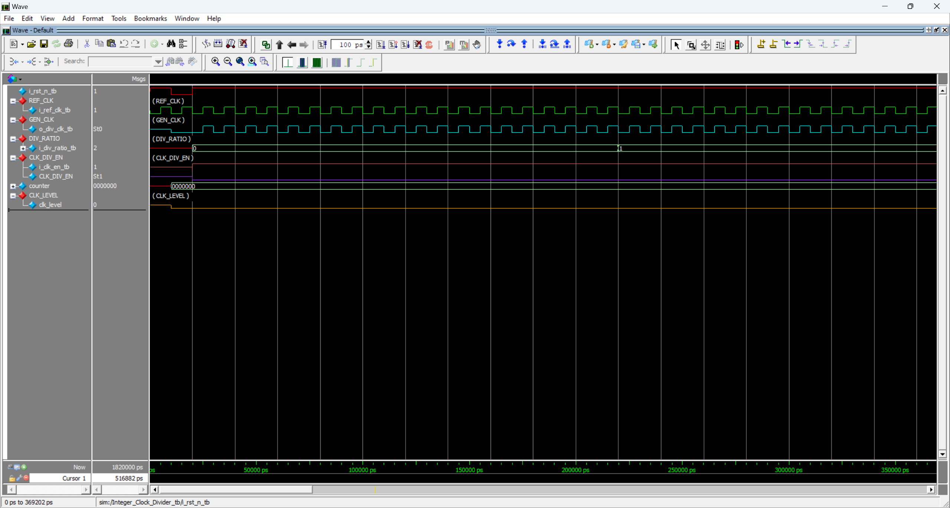

Figure 1: Start of the simulation, the divided ratio is 0 or 1. Therefore, the generated clock is the same as the reference clock.

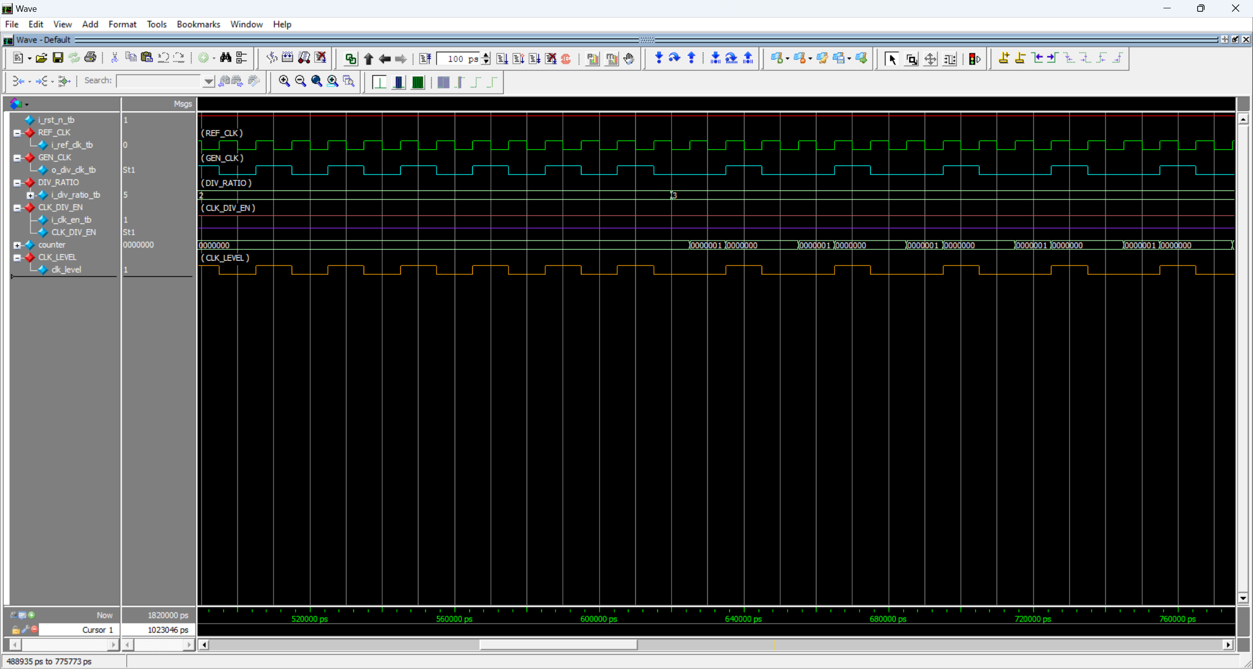

Figure 2: The generated clock when the division ratio is 2 and 3.

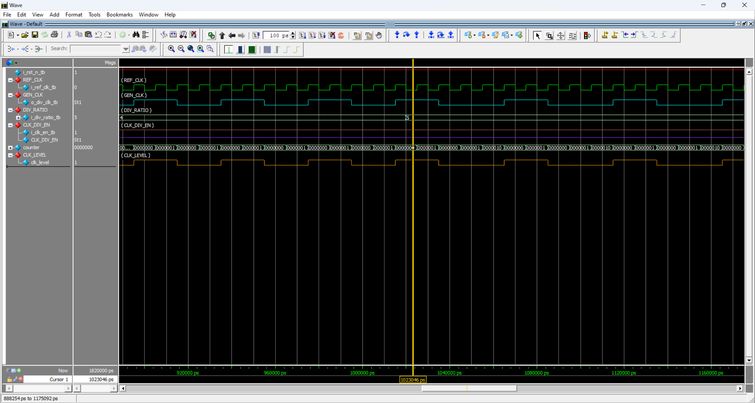

Figure 3: The generated clock when the division ratio is 4 and 5.

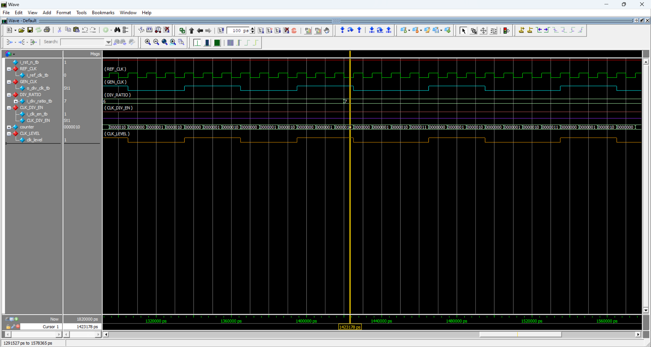

Figure 4: The generated clock when the division ratio is 6 and 7.

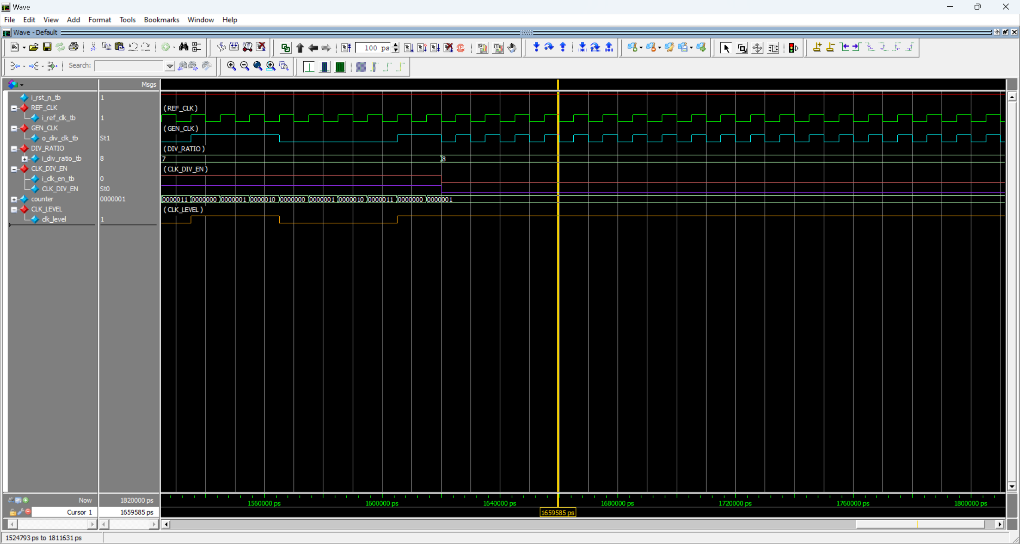

Figure 5: The generated clock when the clock enable is 0 which is the same as the reference clock.